Project Thryva

**Project Members (Group 13)**

* Ramon Fritz
* Robert T
* Paul Harmer

**Project Description**

Project Thryva is a stream-lined motivational To-Do app that encourages mindfulness and provides users with a daily an inspirational image and quote to help them to complete their most important task that day.

**User Story**

As a busy professional, I want to be motivated, inspired and focused so that I can complete my most pressing action of the day.

**Mock Up**

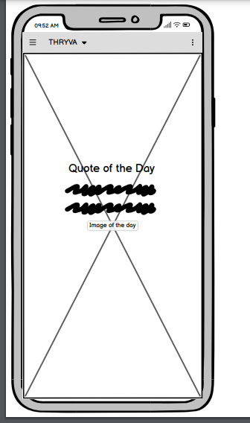

**APIs**

There will be 2 external API’s needed –

1. An API to provide daily Inspirational images
2. An API to provide daily inspirational quotes

**Local Storage**: The app will also use local storage to store the supplied quotes and images as well as the daily tasks provided by the user.

**Key Tasks Overview**

**TODAY**

|  |  |
| --- | --- |
| **ACTIONS** | **ACTION OWNER** |
| Decide what app to build | Group |
| Decide on app functionality | Group |
| Split up key tasks | Group |
| Mock up app design | Ramon |
| Set up Github Project and Task Board | Robert |
| Write and submit Project Proposal | Paul |
|  |  |

**THIS WEEK**

|  |  |
| --- | --- |
| **ACTIONS** | **ACTION OWNER** |
| Investigate and implement Image API | Paul |
| Investigate and implement Quote API | Ramon |
| Front End Design | Robert |
| To Do button Functionality | Robert |
| Local Storage solution | Paul |
|  |  |
|  |  |

**NEXT WEEK**

|  |  |
| --- | --- |
| **ACTIONS** | **ACTION OWNER** |
|  |  |
| UAT | Group |
| Bug Fixing | Group |
| Prepare Presentation | Group |